**Project Design Phase**

**Solution Architecture**

|  |  |
| --- | --- |
| Date | 28 June 2025 |
| Team ID | LTVIP2025TMID59701 |
| Project Name | BOOKNEST: WHERE STORIES NESTLE |
| Maximum Marks | 4 Marks |

***Solution Architecture:***

Solution architecture is a complex process that bridges the gap between business problems and technology solutions. Its goals are to:

* Find the best tech solution to solve existing business problems.
* Describe the structure, characteristics, behavior, and other aspects of the software to project stakeholders.
* Define features, development phases, and solution requirements.
* Provide specifications according to which the solution is defined, managed, and delivered.

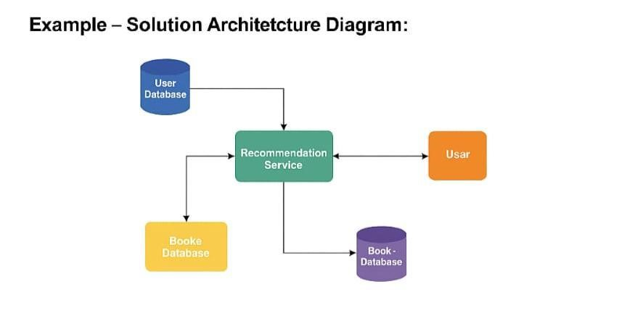

**Example – BookNest Solution Architecture:**

Architecture Diagram goes here: e.g., Frontend (React) → Backend (Node.js/Express) → DB (MongoDB), Auth, Admin Panel, User Services, Recommendation Engine, etc.

***Reference:***

https://aws.amazon.com/architecture/